**Tobor Inc.**

**Content Aggregator App**

**Detailed Process Description**

**Version 1.0**

**Revision History**

|  |  |  |  |
| --- | --- | --- | --- |
| Date Issued | Version | Description | Author |
| 12/05/2020 | 1.0 | Draft | G Wilson |
|  |  |  |  |

**Contributors**

|  |  |  |
| --- | --- | --- |
| Name | Role | Area |
| G Wilson | RPA Consultant | QA Ltd |
| Chris Lucas | Consultant Project Liaison | QA Ltd |
| David Bradbury | Managing Director | Tobor Inc. |
| Roberto Fernandez | Backend Application Manager |  |

**Business Sign-off**

|  |  |  |
| --- | --- | --- |
| Name | Department | Responsibility |
| David Bradbury | Managing Director | Sign Off |
| Roberto Fernandez | Backend Application Manager | Information |
| Chris Lucas | Project Manager | Information |

**Document Classification**

|  |  |
| --- | --- |
| Classification | Company Confidential |
| Definition | Application information is confidential and to be kept by Roberto Fernandez |
| Context | Customer details are to be kept securely and confidential within the company. Failure to do so would result in a negative impact to the credibility of the company. |

**Contents**

**1. Introduction** 4

**2. Manual Process** 4

**2.1 Overview** 4

**2.2 Detailed Process Flow** 5

**3. Automation Proposal** 5

**3.1 Overview** 5

**3.2 Automation Process Flow** 6

**3.3 Target System & User Requirements** 6

**3.4 Impacted Business Areas** 7

**3.5 Workload** 7

**3.6 Operational Constraints** 7

**3.7 Delivery** 7

**3.8 Contact List** 7

**4. Automation Details** 8

**4.1 Automation Walkthrough** 8

**4.1.1 Robot Processes User Request** 8

**4.1.2 Robot Aggregates Content** 8

**4.1.3 Robot Processes Report** 9

# **1. Introduction**

The content aggregation process is a lengthy procedure carried out by the development department at Tobor Inc. The app has had a great response from launch however, this has caused the development department to struggle as the app relies on manual backend interaction.

The application gathers content from several websites, formats the content into an organised and readable document that it then sent to the user.

The user journey consists of a registering process, in which the user must give the credentials required of them. This is then sent to the company, where it will then be collected and stored into an internal database. The company then sends the newly registered user a receipt, informing them that they have been added.

It’s been determined that it is an excellent candidate for process automation as it is a repetitive and extensive process. This document will focus on developing an automated process for the manual process Tobor Inc. currently have implemented for content aggregation.

# **2. Manual Process**

## **2.1 Overview**

The process begins when Tobor Inc. receive a user request, containing the user details, via email.

The backend application manager is then responsible for processing these details and will carry out the following steps:

* Process user email
  + New user – add user to database
  + Existing user – handle request
    - Update – update details and record user action
    - Deletion – remove from database
* Aggregate content from sites based of users’ preference
* Check for repeat content and any duplicates
* Tidy content
* Send content to user at the interval
* Record items against content transmission
* Create daily PDF report
* Send PDF report to Tobor Inc.

## **2.2 Detailed Process Flow**

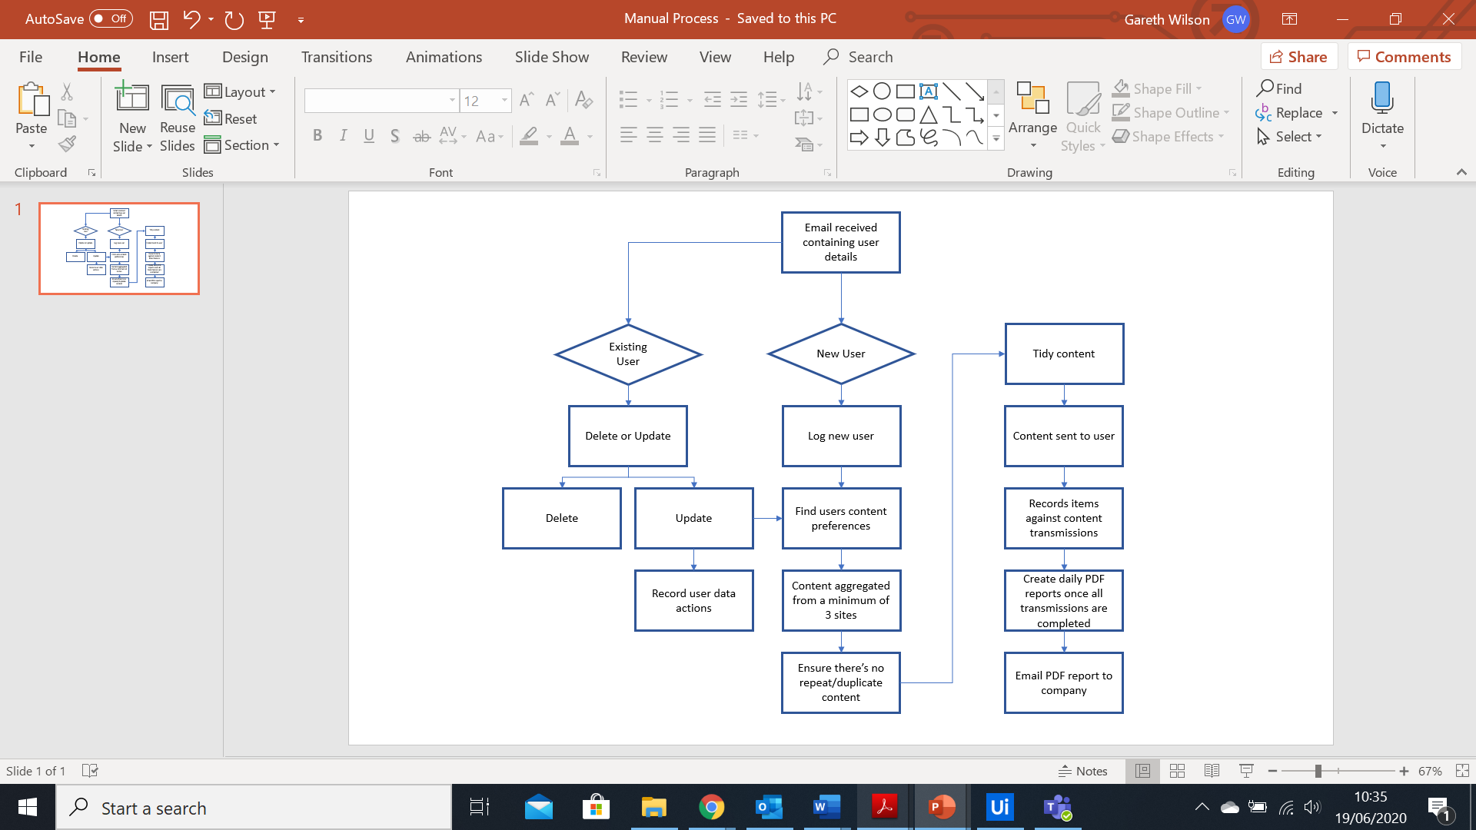

# **3. Automation Proposal**

## **3.1 Overview**

The diagram above displays the manual process, detailing the end-to-end process of the content aggregation.

QA Ltd propose to integrate automation for the entire process – allowing for a more efficient and streamlined process.

User Registration Process:

* Scan Tobor inbox for “REGISTRATION” emails
* Scrape the user details from the email
* Insert user details into the user database
* Send user a receipt
* Log the new user to be put in the daily report

User Update Process:

* Scan Tobor inbox for “UPDATE” emails
* Scrape the user details from the email
* If the users ID matches the ID of the user in the database, change the fields within that row
* Send user a receipt
* Log the updated user to be put in the daily report

User Delete Process:

* Scan Tobor inbox for “DELETE” emails
* Scrape the user details from the email
* If the users ID matches the ID of the user in the database, remove row
* Send user a receipt
* Log the deleted user to be put in the daily report

Content Aggregation Process:

* Read users content preference from the database
* Content scraped from websites relevant to that user
* Content stored and formatted for user
* Content is then placed in an email and sent to the user at the desired intervals outlined in the database

Report Process:

* Activity within the application is logged daily
* It is collected and stored in a PDF
* The report PDF is then sent to the Backend Application Manager

## **3.2 Automation Process Flow**

The automated process will replicate the current manual process Tobor Inc. has in place. All sections carried out by the Backend Application Manager will be automated.

## **3.3 Target System & User Requirements**

|  |  |  |
| --- | --- | --- |
| Name | Description | User Permissions/Access |
| MS Outlook | Email Inbox | Used to simulate the company’s email |
| Gmail | Email Inbox | Used to simulate the users email |
| User Database | Written in MS Excel | Used to simulate the Tobor Inc. internal database |

## **3.4 Impacted Business Areas**

* Backend Application Manager

## **3.5 Workload**

The following metrics have been provided by the Backend Application Manager.

|  |  |
| --- | --- |
| Max. no. of requests per week | 130 |
| Min. no. of requests per week | 10 |
| Are there any periods when a higher workload is anticipated? | A spike around major news stories and/or sporting events. |
| How many people do this process per day? | 1. Roberto Fernandez, Backend Application Manager. |

The Backend Application Manager spends approximately 50% of his day handling the increasing user database. The statistics below are calculated based off the information gathered from Roberto Fernandez.

User Actions (register, update, delete):

* 15 minutes x 40 (35 registrations + 10 updates/deletes) = 600 minutes (10 hrs)

Content Aggregation:

* 3 hours + 1 hour (to distribute content emails) = 4 hrs

Reports:

* 1 hour

Total:

* 10 + 4 + 1 = 15 hrs daily.

On average, the manual process takes 15 hours to process daily. The automation of this process would save Tobor Inc. 75 hrs a week.

## **3.6 Operational Constraints**

Tobor Inc. have a cut off point at 11:30, this means any users who try to register, update or delete themselves after this time will not be process until the next day.

Content is then aggregated after the 11:30 cut off and sent to the users within the database.

## **3.7 Delivery**

The process was originally to be delivered by the 26th of June 2020, however the deadline for this project has been extended to the 29th of June 2020.

## **3.8 Contact List**

David Bradbury – Managing Director

Roberto Fernandez – Backend Application Manager

Chris Lucas – Project Manager

# **4. Automation Details**

## **4.1 Automation Walkthrough**

## **4.1.1 Robot Processes User Request**

* Scan Tobor inbox
* Opens unread email
* If email has “REGISTRATION” as the subject
  + Scrape the user details from the email
  + Store data scraped from email
  + Send user a receipt allowing user to know their request has been received
  + Insert user details into the user database
* If email has “UPDATE” as the subject
  + Scrape the user details from the email
  + Store data scraped from email
  + Send user a receipt allowing user to know their request has been received
  + Compare the ID scraped from the email to the user in the database
  + If ID matches, rewrite the fields within that row
* If email has “DELETE” as the subject
  + Scrape the user details from the email
  + Send user a receipt allowing user to know their request has been received
  + Compare the ID scraped from the email to the user in the database
  + If ID matches, remove user from database

## **4.1.2 Robot Aggregates Content**

* Dispatcher:
  + Reads the database
  + Adds all user details from database to a queue created in orchestrator
* Content is aggregated from three websites per content preference (gaming, film and sport have been used within this process)
  + The application navigates to the website
  + Data is then scraped from the websites
  + The tab is the closed
  + The aggregated data is then stored
    - This process is repeated for the other two websites within that preference
* The queue is then called
* A flow decision with a condition then processes the users within the queue
  + If the condition is false, the process will email the users within the queue
    - if statements then direct the process dependant on whether the users content interval is weekdays or daily.
    - The process then reads their content preference and delivers the relevant content.
    - The content is formatted to make it clean and readable for the user and sent
    - A transaction status is then set to show whether the email has been sent successful or not.
* Once it has iterated through the entire queue within orchestrator, the condition is true ad a message box appears, informing the user that all the emails have been sent

## **4.1.3 Robot Processes Report**

* The robot scans the emails within the sent items folder
* For each email containing “Weekdays” in the subject, it will target the following elements within the email:
  + - First name, last name, transmission time, content preference, first piece of content
  + These elements are then written into a word document
  + The word document is then exported to a PDF
* For each email containing “Daily” in the subject, the same process occurs.
* The robot then scans the emails within the inbox folder
* For each email containing “REGISTRATION” in the subject, it will target the following elements within the email:
  + - First name, last name, transmission time, email subject
  + These elements are then written into a word document
  + The word document is then exported to a PDF
* For each email containing “UPDATE” or “DELETE” in the subject, the same process occurs.
* Finally, the finished PDF report containing all the information is sent to Tobor Inc.